**CSE 3001**

**Software Engineering**

**Student Activity Detection using Cursor Tracker**

**Team number - 11**

Apoorv Yadav - 19BCE1163

Shushant Kumar Singh - 19BCE1620

Tanmay Mahajan - 19BCE1735

**Index**

|  |  |
| --- | --- |
| **Title** | **Page No.** |
| 1. **Class Diagram** | **3** |
| 1. **Use Case Diagram** | **4** |
| 1. **Sequential Diagram** | **5** |
| 1. **Work Breakdown Structure (WBS)** | **6** |
| 1. **Dataflow Diagram** | **7** |
| 1. **State Diagram** | **8** |
| 1. **Activity Diagram** | **9** |
| 1. **State Diagram** | **10** |
| 1. **Deployment Diagram** | **11** |
| 1. **Test Cases** | **12** |
| 1. **Screen shots of the developed program** | **13** |

1. **Class Diagram**

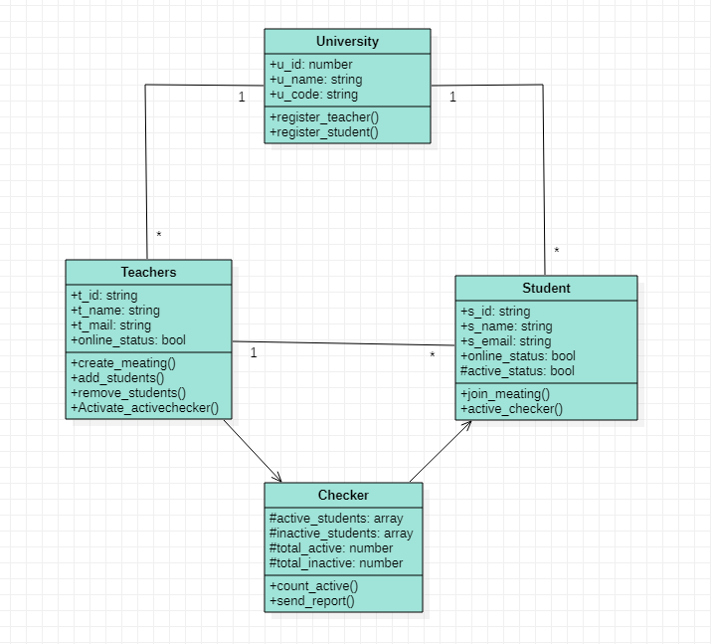

1. **Use Case Diagram**

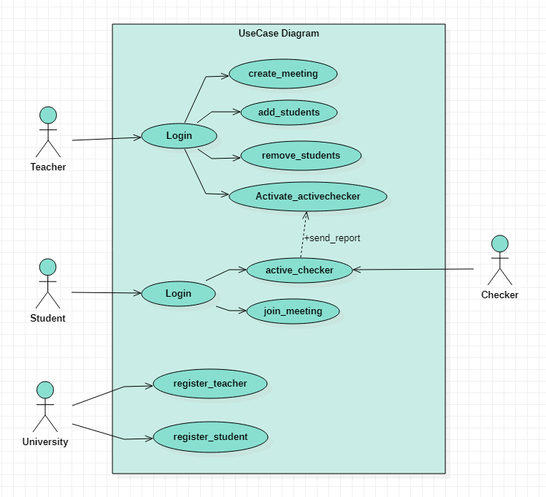

1. **Sequential Diagram**

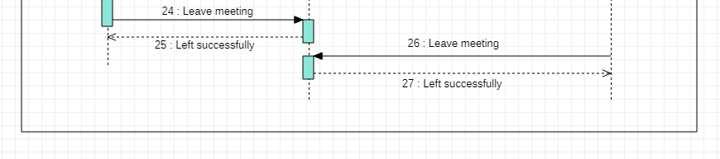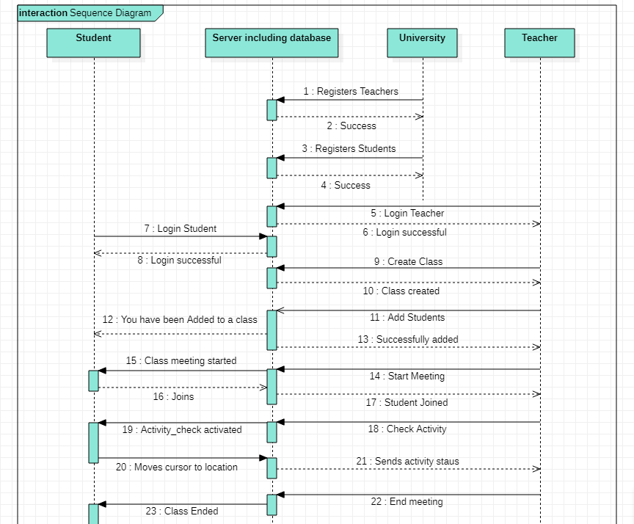

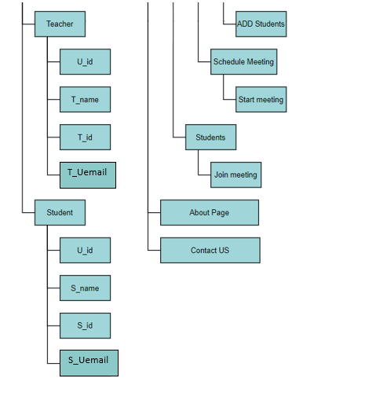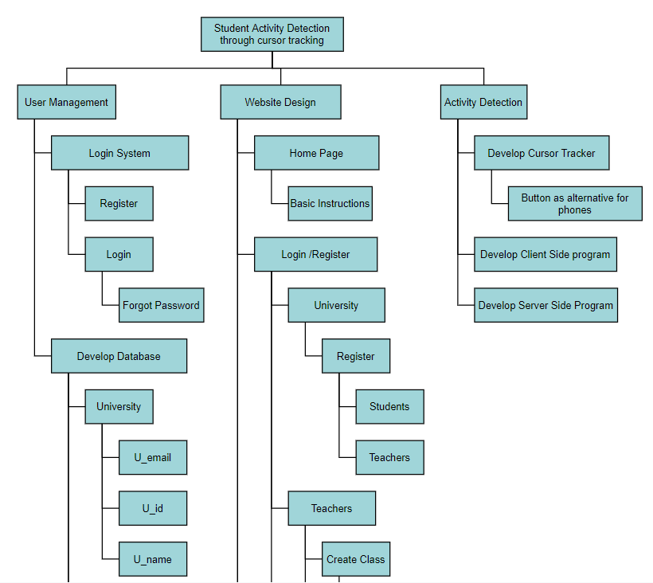**4.Work Breakdown Structure**

**5. Data Flow Diagram**

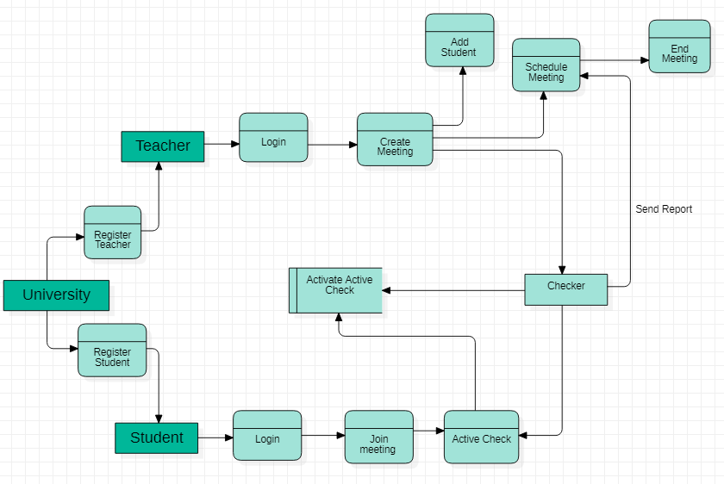

1. 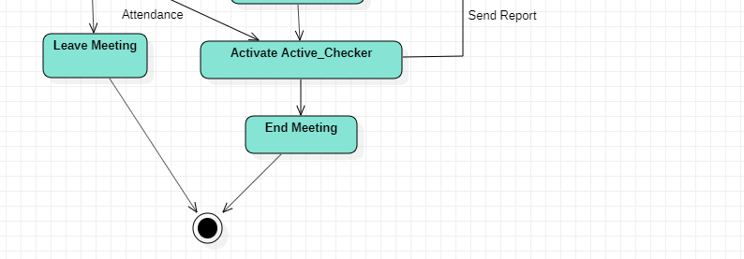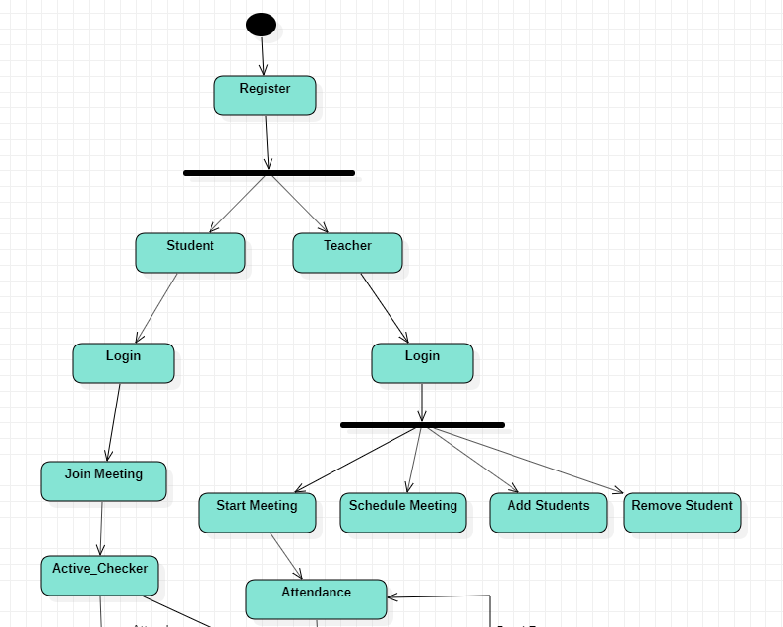**State Diagram**
2. **Activity Diagram**

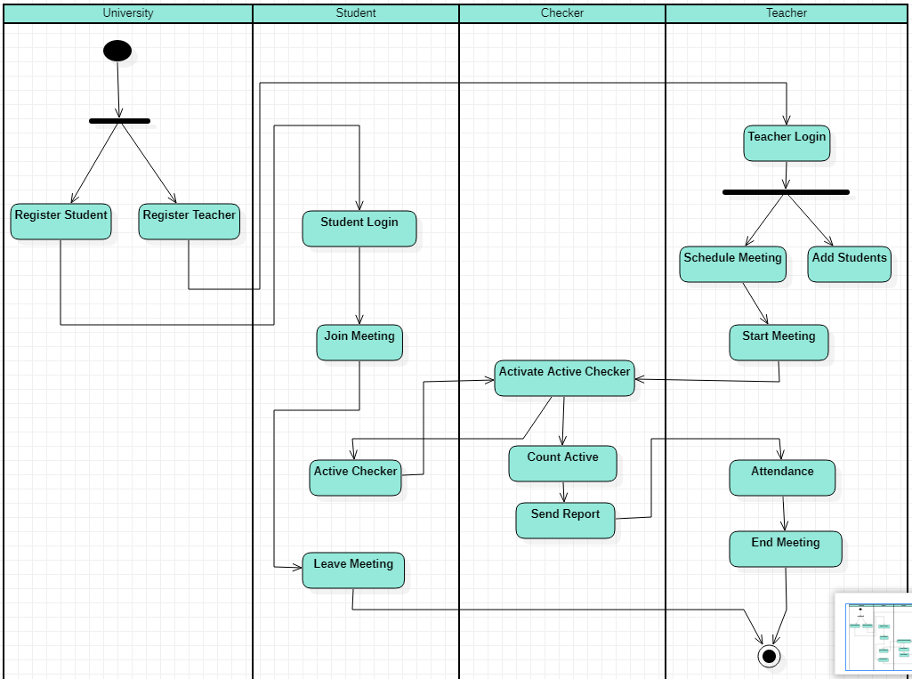

1. **Deployment Diagram**

